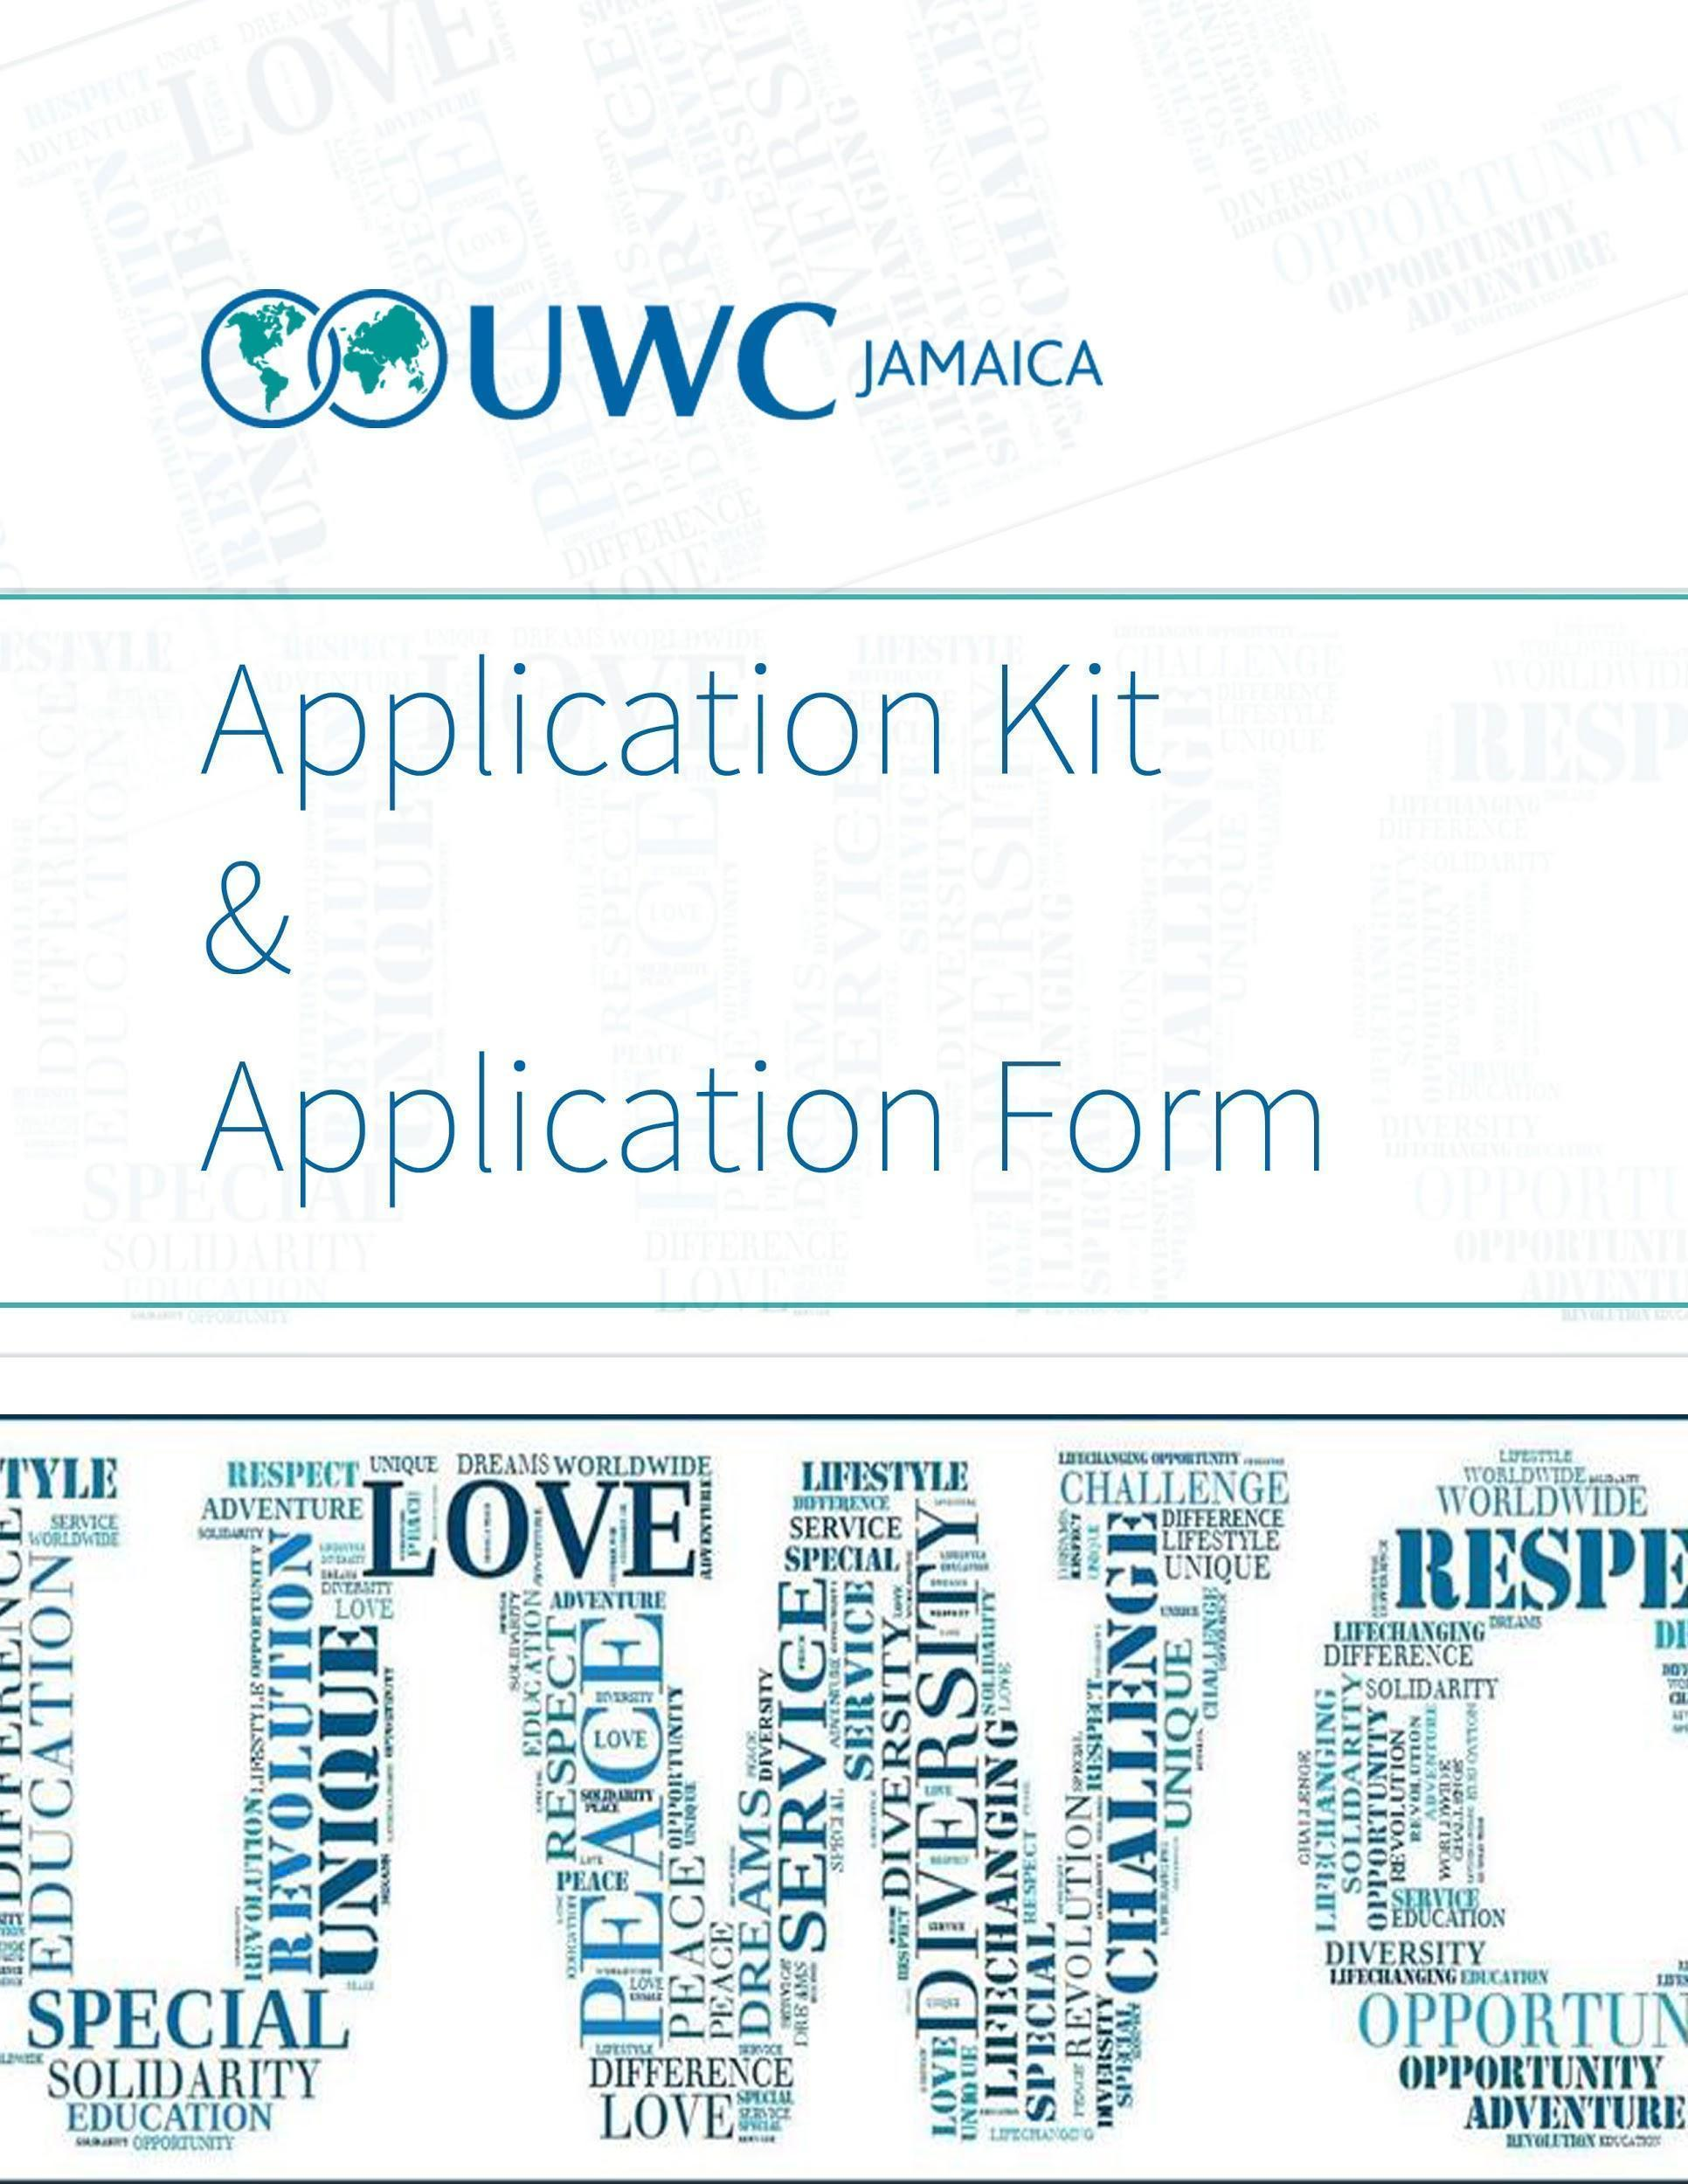

If you are submitting via email, please remember to change the name of this document to include your name before you submit.
Instructions: The goal of this application process is to understand who you are as a young person and how UWC can help you become who you would like to be as an adult. The committee is trying to determine whether attending UWC will help you to succeed, based on who you are as a whole person: your values, vision, interests, accomplishments, capacities, choices, struggles, and engagement with the world around you. Therefore, share with us specific information that comes from your own experiences and perspectives. We discourage the use of AI, such as ChatGPT, because the answers it generates are generic and will not give us a consistent and true representation of who you are as a unique individual.

Application Form

This form is for internal UWC purposes only. The information collection will not be shared beyond UWC Jamaica selection committee administrators.

Personal information

Surname(s):
Legal first name(s):
Preferred Name
(if different for first name):
Middle name (only if noted on passport):
Sex:
Do you identify with a different gender to the sex you were assigned at birth? | - Yes  - No  - Prefer Not to Say
Gender
If you answered yes to the question above, enter your gender identity here.
Date of birth (dd/mm/yyyy):
Country of Birth
Country of Residence
Country of citizenship (on which passport would you travel)
Do you have a valid passport? | - Yes  - No

Contact Information

Email address:
Cell phone:  (876-###-####) | 876-###-####
Does this cell phone number have a Whatsapp associated with it? | - Yes  - No
Home Phone:  (876-###-####) | 876-###-####
Permanent Home Address
Address line 1:
Address line 2:
City:
Province/ Territory/ Region:
Country:
Courier Address
(to receive posted mail, if different from home address)
Address line 1:
Address line 2:
City:
Province/ Territory/ Region:
Country:

How did you hear about UWC?

How did you hear about UWC?
- Teacher/Guidance Counsellor
- Principal
- College Counsellor
- Friend/Family
- Alumni
- Internet
- Social Media
- Other _________________

Optional: UWC runs short courses and summer programmes to bring a UWC education and the UWC mission to a wider audience. Every short course is different, but they are usually residential and take place over one to three weeks. The courses are experiential and immersive, typically bringing together 30 - 60 young people from different backgrounds. As part of this application process you may choose to also be considered for a short course, in particular if you are unsuccessful with your application for a 2 year programme.

The answer you give below will not affect your chances of being offered a place in one of the UWC schools or colleges.
- Yes
- No

Parent/Guardian Information

This form is for internal UWC purposes only. The information collection will not be shared beyond UWC Jamaica selection committee administrators.
Please provide up-to-date contact information about your guardian(s)/parent(s).

If short-listed, parent(s)/guardian(s) will be required to provide further information about themselves.

Parent/Guardian #1: (This must be someone who has a legal duty of care over the applicant)

Relationship to student:
Last name
First name/ given name(s):
Home Address (if different from Student’s)
Cell Phone:  (876-###-####)  Associated with WhatsApp if possible | 876-###-####
Email Address
Occupation
Annual Net Income:
(JMD)

Parent/Guardian #2 : (If Applicable)

Relationship to student:
Last name
First name/ given name(s):
Home Address (if different from Student’s)
Cell Phone:  (876-###-####)  Associated with WhatsApp if possible | 876-###-####
Email Address
Occupation
Annual Net Income:
(JMD)

Health information
This form is for internal UWC purposes only. The information collection will not be shared beyond UWC Jamaica selection committee administrators. Shortlisted applicants may be required to provide further information later.

 |  | If yes, please provide details, including dates and time frames when applicable
Do you consider yourself to have a disability?  (A disability is an impairment that has (or is likely to have) a substantial, adverse, long-term effect on the ability to carry out normal day-to-day activities.) | - Yes  - No
Do you have any additional health needs?  (for example: you take regular medication, allergies) | - Yes  - No
Do you take any medication, including non-prescription, regularly? (Please include allergy tablets, birth control, vitamins, and minerals.)  Will you bring this medication to the school/college? | - Yes  - No
Have you ever required treatment or hospitalization for any surgical, medical, or mental health condition? | - Yes  - No
Have you ever had or do you currently have any mental health concerns, such as depression, anxiety, suicidal thoughts or attempts, self-harm, eating disorders (anorexia nervosa, bulimia), disturbance of mood, thought or behaviour? | - Yes  - No
Have you ever received care or treatment from a mental health practitioner or facility? | - Yes  - No
Do you have any learning difficulties? | - Yes  - No
Do you have limited mobility? | - Yes  - No

School information

Please provide information about your current or most recent schooling.

Name of School:
School Address
What type of school is this school? | - Government Funded  - Private  - International School  - Residential or Boarding School  - HomeschoolOther: ______________
Number of years spent at this school
Did you receive a scholarship at your current/last attended school?
If yes, please provide details of the scholarship.

School Contact Information

This is not used in the application process, and is rather used for future UWC outreach efforts.

Name of Head of School:
Email of Head of School:
Name of Guidance Counsellor (if any):
Email of Guidance Counsellor (if any):

Academic Information

This section is to get an understanding of your academic progress so far.

What grade are you currently in? | - Grade 11  - Grade 12/Lower 6th Form
What subjects are you taking in school this year? | List subjects here:

NOTE: When submitting your application, also attach your report for last year, as well as a current year report card if applicable.

External Exams
If you are in Grade 11 but you’ve already taken some subjects at the CSEC/CAPE/Other qualification level, list the subject(s) and your score(s).

If you are in Grade 12, list all the subjects you have completed at any level of CSEC/CAPE/Other qualification, including your scores.

Subject | Grade | CSEC, CAPE, Other qualification (Please state, e.g., City and Guilds)
E.g. Advanced Jumping Jacks | 5 | CAPE

NOTE: When submitting your application, for all subjects listed, a CXC certificate must be submitted with the application.

Subject Choice
We would like to know how your CSEC/CAPE/Other subject choices represent who you are and who you would like to be.
If you had to choose your subjects again, would you keep or change any of them to accomplish your long-term goals? If you did not choose any of your subjects, do you wish they were different in order to accomplish these goals?
Word Limit: 50-150

Extra Curriculars
UWC is more than just the academic performance. We would like to know who you are in and outside of your classroom.
Describe in two sentences each of your extracurricular activities (in and/or outside of school) including what your role in the activity is? For example, clubs, creative activities, employment, sports, volunteer projects, or other hobbies.
List up to 6.

Activity | Description of what the activity is and how you are involved. | How many years have you been involved

We would like to understand how your time outside of school reflects your interests and values.
Choose the activity you spend the most time on and explain why you choose to spend so much time on it.
Word Count: 100-200

Written Responses
Remember! The goal of this application process is to understand who you are as a young person and how UWC can help you become who you would like to be as an adult. The committee is trying to determine whether attending UWC will help you to succeed, based on who you are as a whole person: your values, vision, interests, accomplishments, capacities, choices, struggles, and engagement with the world around you. Therefore, share with us specific information that comes from your own experiences and perspectives. We discourage the use of AI, such as ChatGPT, because the answers it generates are generic and will not give us a consistent and true representation of who you are as a unique individual.
UWC candidates have a wide range of personalities and passions. We want you to tell us about your motivations, your values and what you might gain from a UWC education and the International Baccalaureate.
For each of the following questions there is no right answer, but we do expect your answers to be honest and truthful. Your answer should tell us about your ideas, interests and experiences in your own words.
Please note that all answers must be in English.

Short Answer Questions
Answer the following three questions with one sentence only.
Question 1
What has brought you joy recently?
Question 2
Where do you feel most at peace?
Question 3
When do you feel most like yourself?

Essay Questions
Question 4
The mission of UWC is to “make education a force to unite people,nations and cultures for peace and a sustainable future.” What (1) experiences, (2) skills and (3) ideas do you have that can help us to achieve this mission?
Your answer may take the form of a numbered/bulleted list or paragraphs. Be sure to draw on your unique experiences, skills and ideas in your answer.
Word Limit 150-300
Question 5
How will attending UWC help you to achieve your (1) personal, (2) academic and (3) professional goals?
Your answer may take the form of a numbered/bulleted list or paragraphs. Be sure to identify your specific and concrete goals for each of the three categories.
Word Limit 100-200
Question 6

We would like to understand your creative thinking and personal values. Answer one of the following questions.

  - Tell us about a local play/dance/theatre/poetry production or performance you have seen. Drawing on examples from your own life, explain why a particular scene or aspect of the performance resonated with you.
  - Tell us about a piece of Caribbean literature (poem, short story, novel or drama) that you read in school. Contrast yourself with the main character or persona. What differences or similarities in backgrounds and life experiences exist between you and them?
  - Tell us about a reggae or dancehall song you are listening to a lot right now. What circumstances in your life make this song relevant to you in this current moment?
  - Share a piece of visual art that you made and tell us about why you made it. If you choose this option, submit a photo/photos of the work, and include your artist statement below.

Word Limit: 100-200 words

If you wish, use this space to share anything else that you think may be important for us to consider when reviewing your application. This can be a space to provide context for your grades or extracurriculars, or anything else you think would help us get to know you. (optional)
Up to 100 words

Attachments

Please remember to attach the following items to your email, when you submit your application. Use the checkbox to indicate that it is attached

Previous Year Report Card(s)
Current Year Report Card
High School Transcript from Previous School, if applicable
Results of any CXC/External Exams Taken
Photo or scan of passport page, if you have one
Photos of Visual Arts Piece, if applicable

